
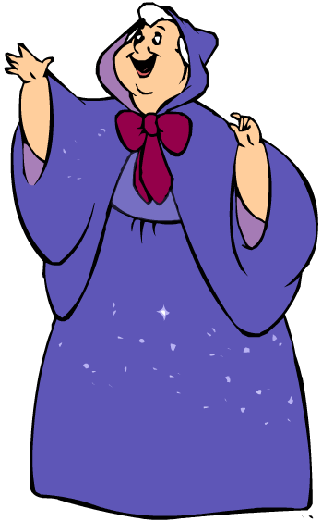
Cinderella

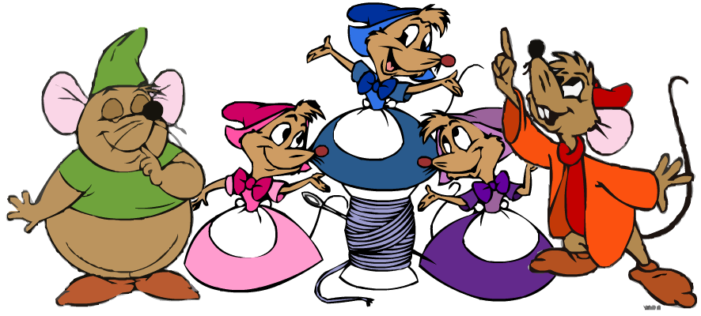

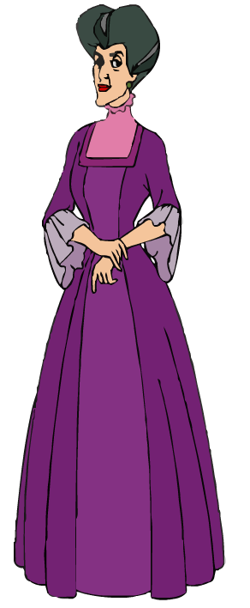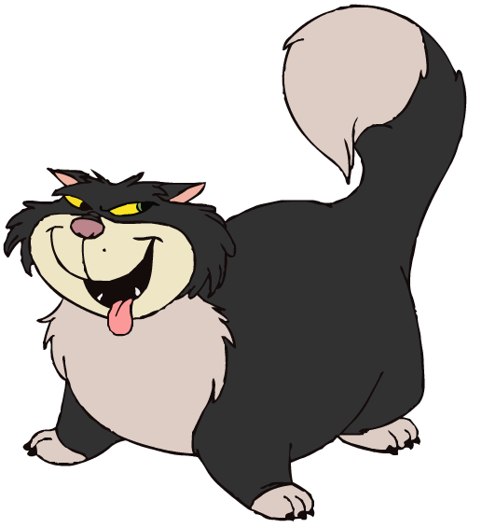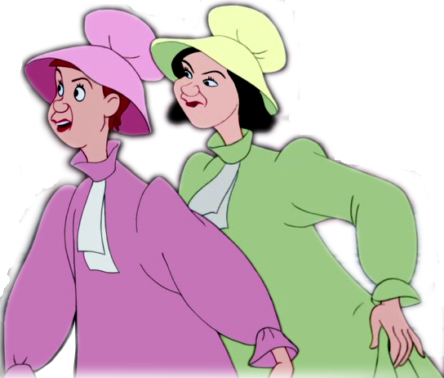
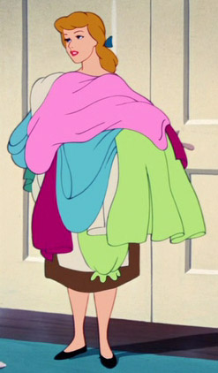
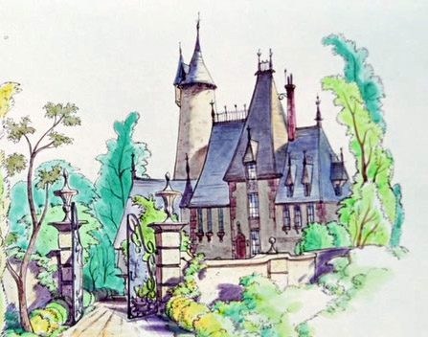

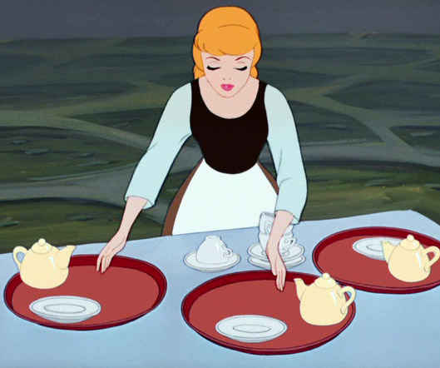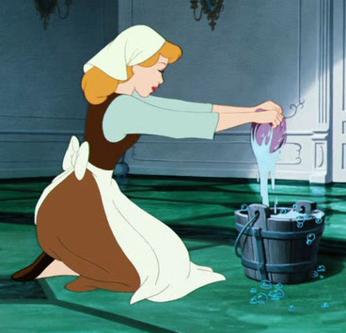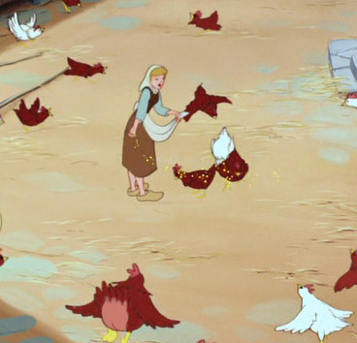

 | 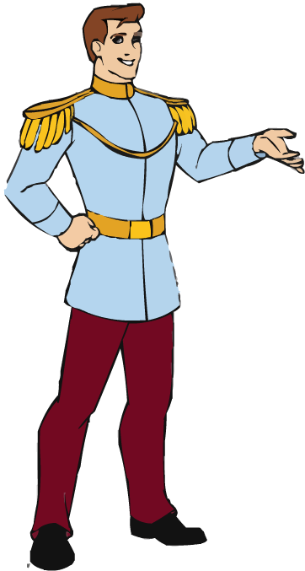 |  | 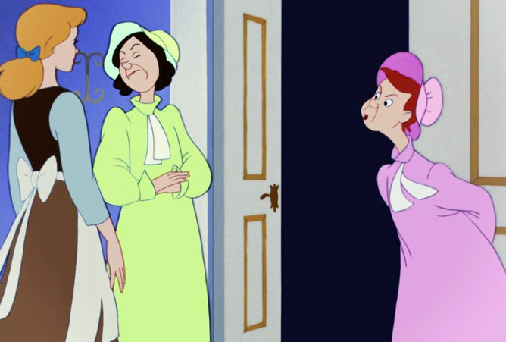
Cinderella
This exercise is for students who are just beginning to study English.
Primary purpose: These character-stories are not actually for speech skill development (it’s a secondary goal here) but to break the very solid pattern ‘SUBJECT + TO BE form’, which many students tend to be very attached to after a month or two of language learning. They often say things like ‘He is lives in London’ or ‘I am know this song’. It is very good for them to practice producing sentences with easy verbs besides ‘to be’ (‘have got’, ‘like, ‘hate’, ‘live’) as well as using them in turns with ‘to be’ sentences.
Secondary purposes: active speech practice, 1st and 3rd persons of verbs, nouns in singular and plural.

The task is not to produce the whole variety of possible sentences, but to practice easy sentences with various verbs making easy stories – within the abilities of each student or with little hints from the teacher. The practice is effective due to repeating the same speech patterns about different characters.
Don’t think there will be any effect if a student comments just one or two characters! To achieve a progress one needs to process five or seven characters – not just telling about them, but also discussing them, doing translations, short written reports, reports about yourself, etc.
Another mistake is to overwork a character nearly learning the story by heart. It’s not required, the speech must remain flexible,

Possible exercises:
1) Character stories: brainstorming, in groups or in pairs, orally or in writing (tell what you can: a) about the character, b) about his or her family and friends, c) place of living, [d ) occupations – this may be too difficult for younger students], e) likes and dislikes.
2) Imagine you are a character and tell (/write) the story (/5/7/10 12 sentences) on behalf of the character.
3) Tell/write a story (/5/7/10 12 sentences) about yourself.
4) Translate some sentences from the mother tongue (prepared by the teacher or, in pairs, made up by the neighbour). Also parallel translations could be done (‘Homer likes sandwiches – We like sandwiches – I like sandwiches…’ or ‘a small town – small towns…’).
5) Compare a character or yourself to another character (say or write what you have in common or the differences: ‘Homer hates to work, but I like to work…’)
6) The teacher or a neighbour in the group says a sentence – you point at the picture (can be restricted to one or many pictures at a time).
7) Guessing who the character is (After saying 3/4/5 true/false sentences about him or her).
8) Look at the poster, tell about the character’s friend or relative (it’s good to change the number: e.g. after Cinderella tell about her sisters).
9) Make a poster about yourself/any character from a book or movie, comment in pairs/write a story.
10) anything else you like

Possible sentences:

This is Cinderella.
She is very beautiful and kind.
She has got a stepmother and two sisters. (They are mean.).
They have a cat. It is very fat (/and mean). It hates Cinderella.
Cinderella has got many (a lot of) friends. They are mice, birds and other animals.
She has got a godmother. Her godmother helps Cinderella. Her godmother is very kind. She is fat.
Cinderella lives in an old beautiful big house (/a castle) (/on a hill).
Cinderella works very much (/a lot).
[She washes the floor. She makes breakfast. She gives food to the hens. She does the laundry (/washes clothes).]
Cinderella loves the Prince.
The sisters hate Cinderella.

(You may also ask the students to tell about Cinderella’s sisters or the friendly mice.)

